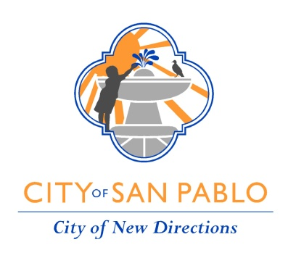

COMMUNITY SERVICES STANDING COMMITTEE
SPECIAL MEETING AGENDA

TUESDAY, MARCH 28, 2023
4:00 PM

Council Chambers
1000 Gateway Avenue
San Pablo, CA 94806

* * * * * * *
Mayor Abel Pineda
Councilmember Arturo Cruz

* * * * * * *

Teleconference Location Pursuant to Government Code section 54953(b)
Mayor Abel Pineda
City Hall, City Council Office
1000 Gateway Avenue
San Pablo, CA 94806

* * * * * * *
CALL TO ORDER/ PLEDGE OF ALLEGIANCE / ROLL CALL

In accordance with the Americans with Disabilities Act and Brown Act, individuals with disabilities requiring reasonable accommodations, including auxiliary aids or services, in order to participate in the meeting should submit a completed Meeting Accommodation Request Form by email to CityClerk@SanPabloCA.gov, with “Accommodation Request” listed in the subject line of the email. Alternatively, completed Meeting Accommodation Request Forms may be submitted to the City Clerk's Office at City Hall, 1000 Gateway Avenue, San Pablo, CA 94806. Meeting accommodation requests should be submitted as soon possible and must be received by the City no later than 10:00 am the day of the meeting for which accommodations are requested. Meeting Accommodation Request Forms may be found on the City’s website HERE, or requested by email to CityClerk@SanPabloCA.gov, or by phone at (510) 215-3000.

PUBLIC COMMENTS
This is the time for comments on any item within the Standing Committee’s subject matter jurisdiction, if such item is NOT listed on today’s agenda. The Committee may not engage in discussion or take action on any item that is not specifically listed on the agenda. That item may be referred to city staff for investigation, report or placement on a future agenda. Persons addressing the Standing Committee are required to limit their remarks to three (3) minutes unless an extension or decrease of time is ordered.

ITEMS FOR COMMITTEE INFORMATION:
- Joint Use Agreement Update
Recommendation: Receive information update; No action required.

- Bi-Annual Youth Commission Presentation
Recommendation: Receive information update; No action required.
ITEMS FOR COMMITTEE ACTION
- Youth Commission By-Laws Amendment
Recommendation:

- Paratransit PILOT Program Update
Recommendation:

ADJOURNMENT

