Weekly Newsletter
For the Week of
5/28/2018 – 6/3/2018

San Pablo Avenue Complete Streets Project
City Project No. SPA-CST
Federal Aid Project No. CML-5303(016)

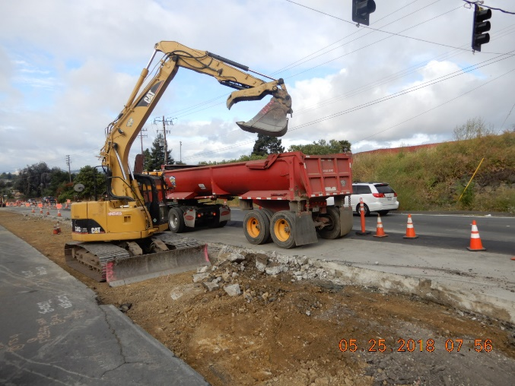
Work Completed This Week
The prime contractor, Ghilotti Brothers, Inc. (GBI), completed construction of the street structural section in the areas where median islands were removed along San Pablo Avenue between Lancaster Drive and Robert Miller Drive. Also, at least one lane of through traffic was maintained in each direction.

Work Forecast for Next Week
GBI is expected to place asphalt concrete pavement in the former median island areas between Lancaster Drive and Robert Miller Drive. GBI is also expected to start the off-haul of excavated soil to the Richmond Park site. Any excess soil will be hauled to other appropriate disposal sites.
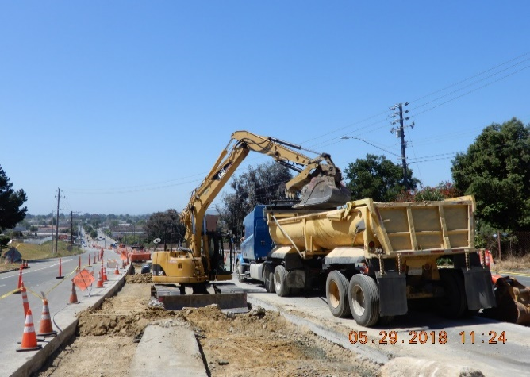
Traffic control is expected to remain mostly unchanged with at least one lane of through traffic maintained in each direction along San Pablo Avenue.

For additional project information, visit the City’s website page at http://www.ci.san-pablo.ca.us or contact the City’s Construction Manager, Jaemin Park at (925) 818-3756 or by e-mail:
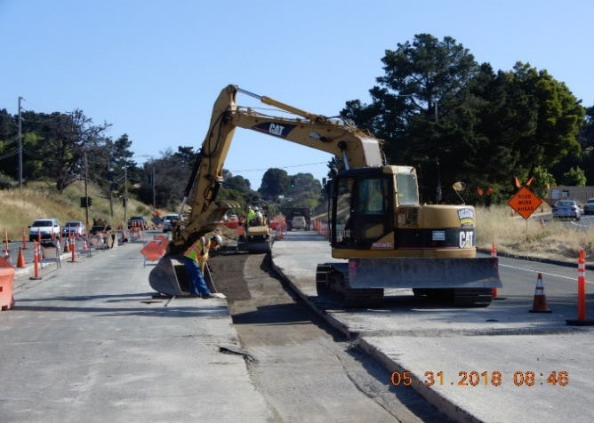
jpark@park-eng.com.

